Mass and Weight Practice

F_{g} = mg g_{earth} = 9.8 m/s²

1) Fill in this chart for the equation.
Variable | Name | Metric Unit
Fg
m
g

2) How many atoms are in something determines its ____________________.

3) How strongly the planet you’re on pulls on you is your ____________________.

4) Your weight will change depending on ________________________________.

5) Your _______________________ never changes despite what planet you go to.

6) Since no equation solves for normal force directly, how can we figure it out how much normal force is acting on an object? It’s equal to ______________________________-

7) When a person goes on a diet, do they really want to lose weight or mass?

8) Hafthor Bjornson broke the deadlift record in April 2020, lifting 501 kg.
A) How much weight (in N) did he lift?

B) How hard was the floor pushing up on the weights when they were on the floor?

9) The weight of a pony standing still on Earth is 1,025 N.

A) What is the pony’s mass?

B) How many Newtons of normal force are acting on the pony?

10) Bob’s mass is 100 kg. Bob can teleport to different planets, fill in this chart.

Planet / Moon | Your Mass on this Planet (kg) | Gravitational Acceleration on This Planet (m/s²) | Your Weight on This Planet (N)
Earth |  | 9.8
Moon |  | 1.6
Jupiter |  | 25.9
Pluto |  | 0.61
Mercury |  | 3.73
Mimas |  | 0.80

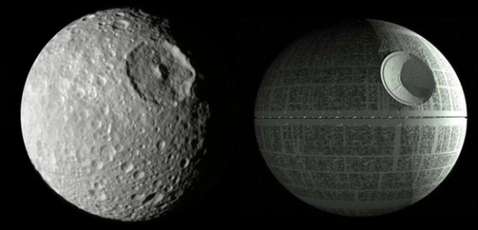

Saturn’s moon Mimas is on the left,
The Death Star is on the right.
Coincidence? WHAT ARE THEY HIDING???????

11) Somewhere you place a 7.5 kg pumpkin on a spring scale. If the scale reads 178.4 N, what is the acceleration due to gravity on that planet?

12) An asteroid weighs 3700N on Earth.

A) What is the mass of the asteroid?

B) The asteroid weighed 1408 N on its home planet. Use the gravitational acceleration chart to solve for which planet or moon it came from.

13) An astronaut weighs 250 N on the moon. How much does he weigh on Earth?

